Create Spring Cloud(Server)

Dependencies

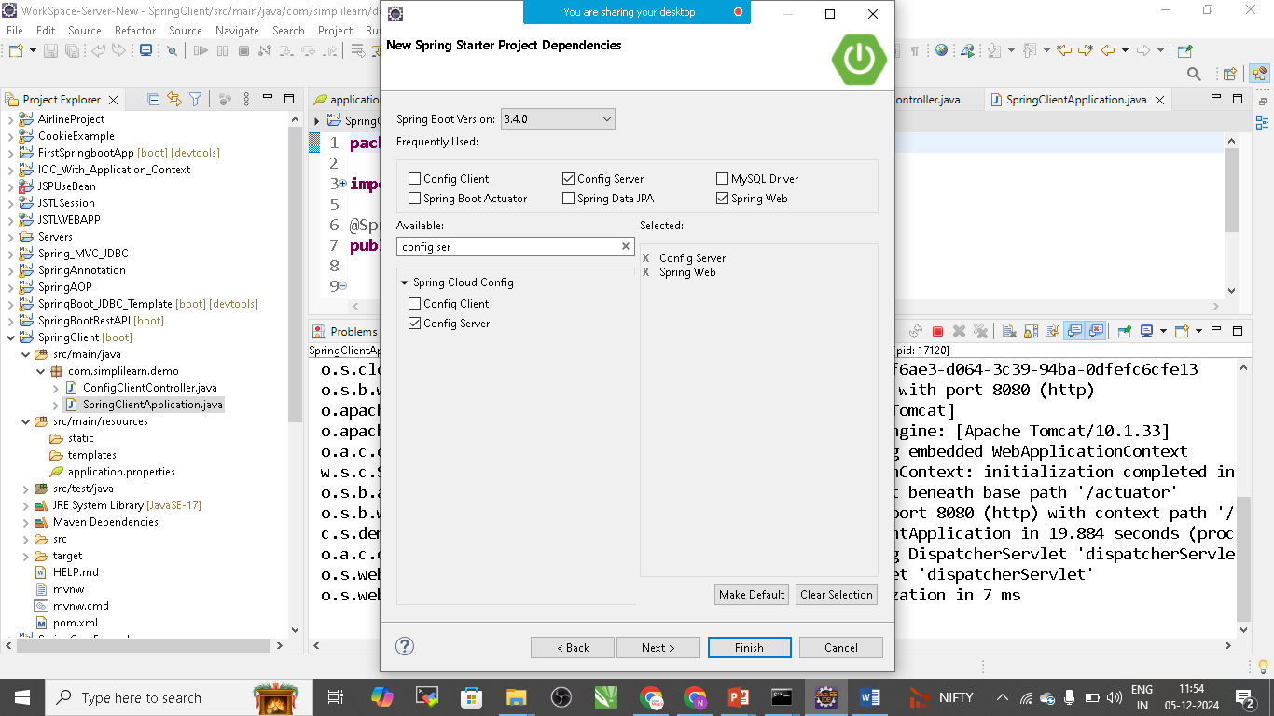

Config Server, Spring web

Application.properties file

spring.application.name=config-server

server.port=8888

spring.cloud.config.server.git.uri=https://github.com/Nikunj-Java/Cloud.git

Note: Create Git Hub Repository and upload application.properties file in github and copy the url here

package com.simplilearn.demo;

import org.springframework.boot.SpringApplication;

import org.springframework.boot.autoconfigure.SpringBootApplication;

import org.springframework.cloud.config.server.EnableConfigServer;

@SpringBootApplication

@EnableConfigServer

public class SpringServerApplication {

public static void main(String[] args) {

SpringApplication.run(SpringServerApplication.class, args);

}

}

Run as Springboot App:

Create Another Spring Boot Application for Client

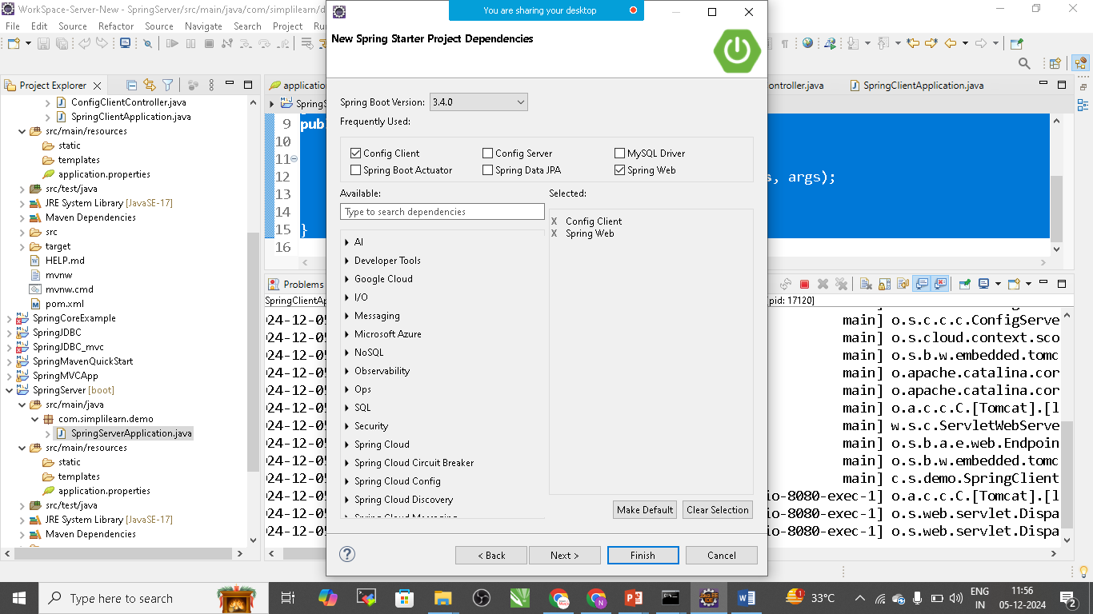

Dependencies: ConfigClient, Spring Web

Application.properties

spring.application.name=config-client

server.port=8080

spring.config.import=configserver:

spring.cloud.config.uri=http://localhost:8888

add controller in client:

**package** com.simplilearn.demo;

**import** org.springframework.beans.factory.annotation.Value;

**import** org.springframework.web.bind.annotation.GetMapping;

**import** org.springframework.web.bind.annotation.RestController;

@RestController

**public** **class** ConfigClientController {

@Value("${app.message: Default Message}")

**private** String message;

@GetMapping("/message")

**public** String getMessage() {

**return** message;

}

}

Run this as Spring Boot App

Server Communication

http://localhost:8888/config-client/default

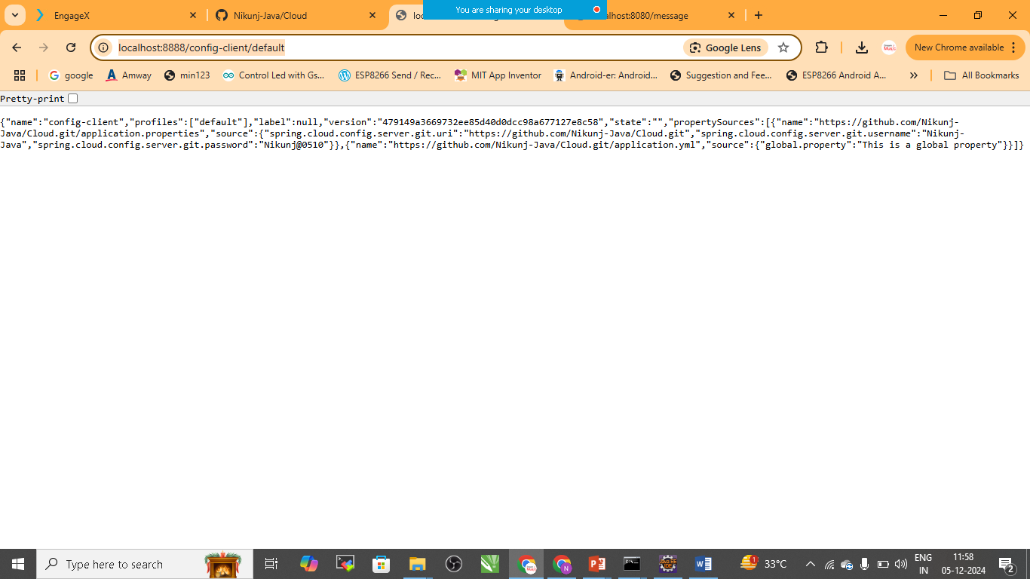

Client Communication: <http://localhost:8080/message>

